***Wine Menu***

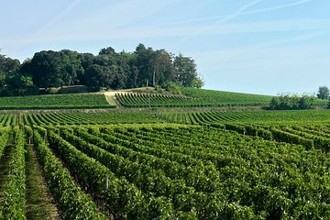

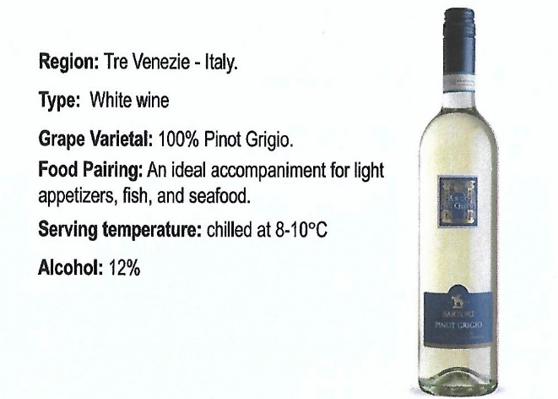***White Wine – Italy Rose Wine – France***



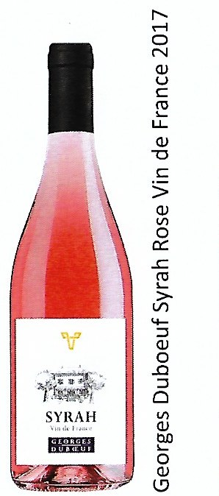

W

***750,-***

***900,-***

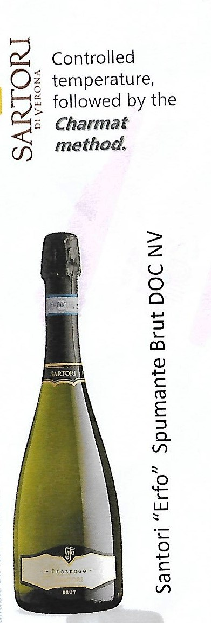***White Wine – Chile Red Wine – Chile***

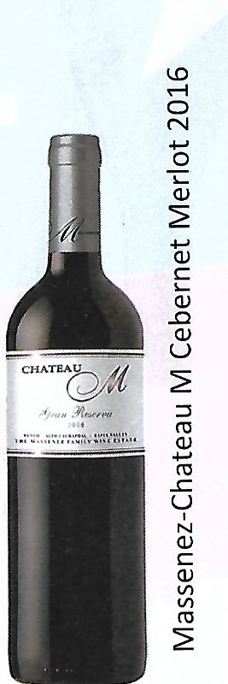

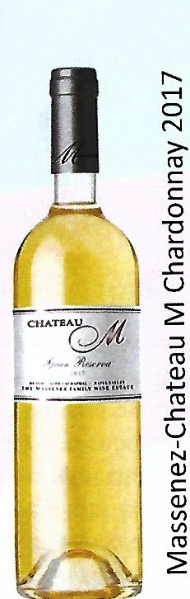

***950,-***

***850,-***

***850,-***

***Wine by the Glass:***

***If you order a second Bottle the Menu Price will be reduced by 150,- ฿***

***Castle Creek - Red 150,-***

***Castle Creek – White 150,-***